WEEK 5
SUBJECT: NUMERACY  Date: |  | Day: MONDAY |  |  | Strand: All Around Us
 |  |  |  |  | SUB STRAND: Gardening
Class: KG 1 |  |  | Class Size:
Content Standard:  K1.6.7.1 Demonstrate understanding of the types of soil |  |  |  | Indicator:  K1.6.7.1.5 classify objects and count the number of objects in each category up to 9
Performance Indicator:  Learners can  - Identify and classify gardening-related objects (e.g., seeds, tools, plants).  - Count and state the number of objects in each group (up to 9).  - Use comparative language such as “more,” “less,” “equal,” and “fewer” to describe quantities. |  |  |  |  | Core Competencies:  Communication and collaboration (CC) Personal Development and Leadership (PL) Creativity and Innovation (CI) Critical Thinking and Problem Solving
Keywords: Plant, stem, root, leaves, fruits
Reference : KG Curriculum P.g. 76-79
Phase/Duration | Learners Activities |  |  |  |  | Resources
PHASE 1: STARTER 10 MINS  (Preparing the Brain for Learning) | Have learners to count and write the number under each group.  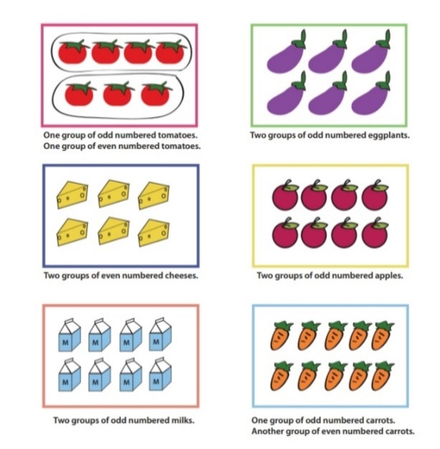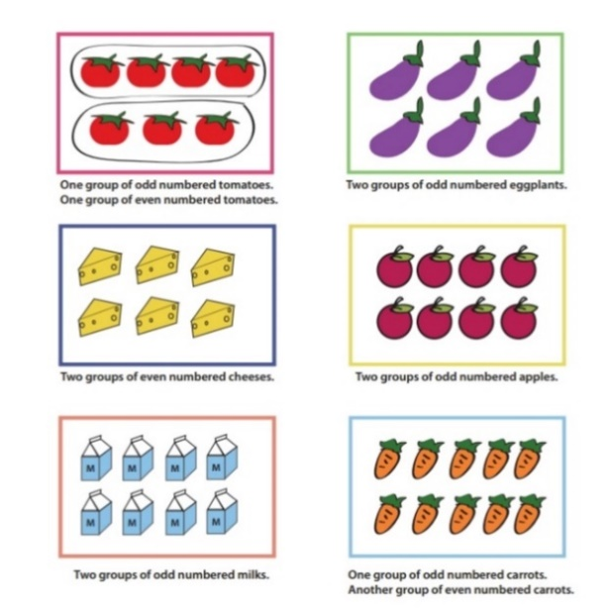  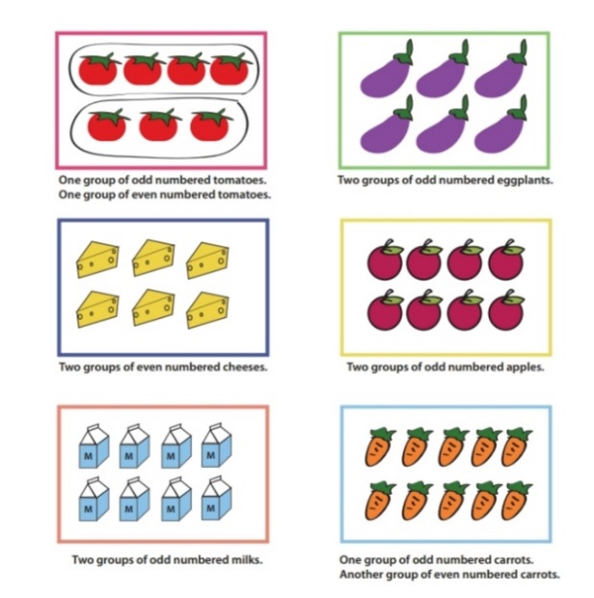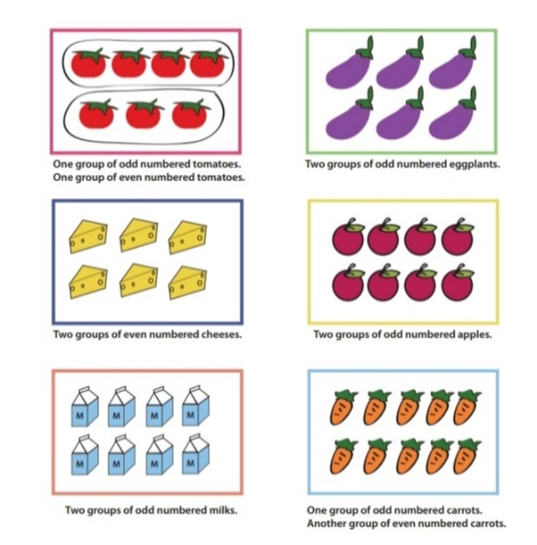  Begin by singing a short garden-themed song (e.g., “Plant a Little Seed”)  Show a tray of different gardening tools and seeds. Ask:  - “What do we use in a garden?”  - “What do we plant?”
PHASE 2: MAIN 40MINS  (New Learning Including Assessment) | Show mixed items (real or pictures) such as seeds, pots, watering cans, and plants.  Ask learners to help group similar items together.  Count the number in each group together aloud (e.g., “1, 2, 3, 4... 4 watering cans!”)  Place number flashcards beside each group.
GROUP ACTIVITY 1  (OUTDOOR) | Place gardening objects around the outdoor area.  Learners find them and bring them to a central spot.  Sort into categories (e.g., tools, plants, seeds).  Count each group with the teacher’s help. |  |  |  |  | Young seedlings, pictures of the types of soil, the big book, plastic containers, counters, soil etc.
PHONICS | Engage learners to sing songs and recite some familiar rhymes that relates to the target sound.  Guide learners to pronounce and write the target sound in the sand tray or exercise books.  Have learners say three or four words that contain the target sound.  Using flash cards, learners read words that contain the target sound.  1. What sound have we learnt today?  2. Which other letter sound do you know?  3. Mention any object in the classroom or home that begins with the target letter sound. |  |  |  |  | Word cards, letter cards.
GROUP ACTIVITY 2  (INDOOR) | Read a concept book (if you do not have numbers concept book, create one) on numbers (1-9) to learners.  Let learners talk about the numbers heard in the reading and show their respective cut out number.  Give learners variety of objects (bottle tops, straws, sticks) ask learners to pick cut out number and count e.g. straws that matches with the particular number on the card  Take Learners out of the class to the field for a stretch up.  Engage Learners to use any of the play toys available.  Make a choice to use any of the learning centers created |  |  |  |  | Letter cards word cards, sentence cards
LEARNING CENTER | Engage learners to play freely at the learning centers.  Observe, join in and ask learners questions frequently to guide their play and to support their understanding in what they are learning. |  |  |  |  | Learning center
STORY SHARING | Tell learners a story.  Pause regularly and ask questions to make sure learners are following.  Engage learners to act parts of the story.  1. Was the story interesting?  2. What part of the story did you like?  3. what have you learnt from the story? |  |  |  |  | Word cards, letter cards.
PHASE 3: REFLECTION 10MINS  (Learner and Teacher) | Review lesson with Learners by singing songs in relation to it  Ask questions like:  - “Which group had more?”  - “Which group had fewer?”  - “Can you show me 6 seeds?”

Date: |  | Day: TUESDAY |  |  | Strand: All Around Us
 |  |  |  |  | Sub Strand: Gardening
Class: KG 1 |  |  | Class Size:
Content Standard:  K1.6.7.1 Demonstrate understanding of the types of soil. |  |  |  | INDICATORS:  K1.6.7.1.4 create words with given sounds and make art works with the elements of art
Performance Indicator:  Learners can  - Identify and blend letter sounds to form simple words (e.g., /c/ /a/ /t/ → cat).  - Create simple artwork using lines, shapes, and colours.  - Talk about their artwork and describe the elements used. |  |  |  |  | Core Competencies:  Communication and collaboration, Critical thinking, Personal Development and Leadership
Keywords: decode, blend, initial, Sound, Word, Line, Shape, Colour, Art
Reference : KG Curriculum P.g. 76-79
Phase/Duration | Learners Activities |  |  |  |  | Resources
PHASE 1: STARTER | Help Henry get to school. Trace the fastest route to school.  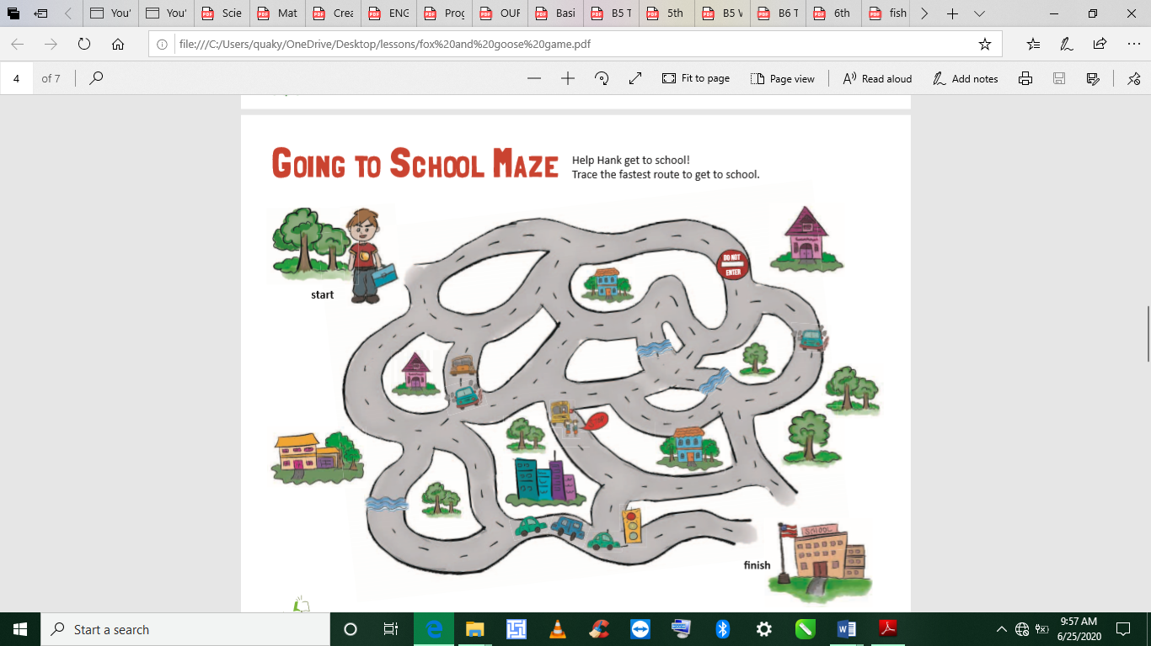
PHASE 2: NEW LEARNING  CIRCLE TIME | Sing a phonics song to revise letter sounds.  Show a few letter cards and ask learners to say the sound (e.g., /s/, /a/, /t/).  Use letter cards to form simple CVC words (consonant-vowel-consonant).  Guide learners to blend the sounds (e.g., /b/ /a/ /g/ → “bag”).  Show matching picture cards and have learners say the word. |  |  |  |  | Young seedlings, pictures of the types of soil, the big book, plastic containers, counters, soil etc.
GROUP ACTIVITY 1  (OUTDOOR) | Hide letter cards outdoors.  Learners find letters and bring them back.  Use found letters to build simple words.  Collect leaves or stones and make outdoor art using lines and shapes.
PHONICS | Engage learners to sing songs and recite some familiar rhymes that relates to the target sound.  Guide learners to pronounce and write the target sound in the sand tray or exercise books.  Have learners say three or four words that contain the target sound.  Using flash cards, learners read words that contain the target sound.  1. What sound have we learnt today?  2. Which other letter sound do you know?  3. Mention any object in the classroom or home that begins with the target letter sound. |  |  |  |  | Word cards, letter cards.
GROUP ACTIVITY 2  (INDOOR) | Read a concept book (if you do not have numbers concept book, create one) on numbers (1-9) to learners.  Let learners talk about the numbers heard in the reading and show their respective cut out number.  Give learners variety of objects (bottle tops, straws, sticks) ask learners to pick cut out number and count e.g. straws that matches with the particular number on the card  Learners sing rhymes and dance with actions  Take leaners out of the class to the field for a stretch up.  Engage leaners to use any of the play toys available.  Make a choice to use any of the learning centers created |  |  |  |  | Young seedlings, pictures of the types of soil, the big book, plastic containers, counters, soil etc.
LEARNING CENTER | Engage learners to play freely at the learning centers.  Observe, join in and ask learners questions frequently to guide their play and to support their understanding in what they are learning. |  |  |  |  | Learning center
STORY SHARING | Tell learners a story.  Pause regularly and ask questions to make sure learners are following.  Engage learners to act parts of the story.  1. Was the story interesting?  2. What part of the story did you like?  3. what have you learnt from the story? |  |  |  |  | Word cards, letter cards.
PHASE 3: REFLECTION | Learners share what they have learnt with their peers and class.  Give learners homework to do at home.

Date: |  | Day: WEDNESDAY |  |  | Strand: All Around Us
 |  |  |  |  | Sub Strand: Gardening
Class: KG 1 |  |  | Class Size:
Content Standard:  K1.6.7.1 Demonstrate understanding of the types of soil. |  |  |  | Indicator:  K1.6.7.1.1 talk about different types of soil and which one is best used for gardening.
Performance Indicator:  Learners can  - Identify different types of soil by sight and touch (sand, clay, loam).  - Understand that plants grow best in loamy soil.  - Engage in discussions and activities related to gardening and soil. |  |  |  |  |  | Core Competencies:  Communication and collaboration, Critical thinking, Personal Development and Leadership
Keywords: Position sentence, blowing breath, blow.
Reference : KG Curriculum P.g. 76-79
Phase/Duration | Learners Activities |  |  |  |  |  | Resources
PHASE 1: STARTER | Engage learners to create a story with the poster below.  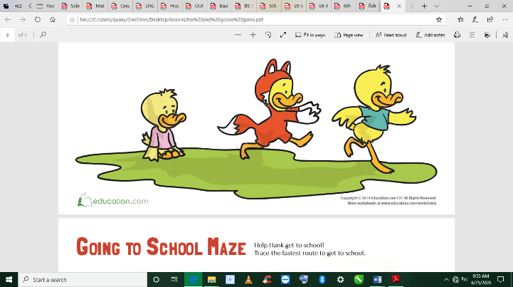  Activity: Mystery Bag  Show children a small cloth bag. Let them guess what's inside. Open the bag and take out a small container of soil. Let them feel it. Say:  - “This is soil! Do you know plants grow in soil? Today we’ll learn about different kinds of soil and which one plants love best!”
PHASE 2: NEW LEARNING  CIRCLE TIME | Show children three clear containers: one with sand, one with clay, and one with loam.  Let each child touch and feel a small amount of each.  Ask questions:  - “How does it feel?”  - “Which is sticky?”  - “Which one is soft and crumbly?”  Explain:  - Sand is dry and rough.  - Clay is sticky and hard when dry.  - Loam is soft, crumbly, and best for plants.
GROUP ACTIVITY 1  (OUTDOOR) | Activity: Soil Hunt & Plant Observation  Go outside with the children.  Let them dig a little and feel the soil.  Guide them to observe which plants are growing best and ask:  - “What kind of soil is this?”  - “Are the plants happy here?”  Help them plant a small flower using loamy soil. |  |  |  |  |  | Sample young plants, pictures, the Big book, pencils and crayons.
PHONICS | Engage learners to sing songs and recite some familiar rhymes that relates to the target sound.  Guide learners to pronounce and write the target sound in the sand tray or exercise books.  Have learners say three or four words that contain the target sound.  Using flash cards, learners read words that contain the target sound.  1. What sound have we learnt today?  2. Which other letter sound do you know?  3. Mention any object in the classroom or home that begins with the target letter sound. |  |  |  |  |  | Word cards, letter cards.
GROUP ACTIVITY 2  (INDOOR) | Read a concept book (if you do not have numbers concept book, create one) on numbers (1-9) to learners.  Let learners talk about the numbers heard in the reading and show their respective cut out number.  Give learners variety of objects (bottle tops, straws, sticks) ask learners to pick cut out number and count e.g. straws that matches with the particular number on the card  Make a choice to use any of the learning centers created
LEARNING CENTER | Engage learners to play freely at the learning centers.  Observe, join in and ask learners questions frequently to guide their play and to support their understanding in what they are learning. |  |  |  |  |  | Learning center
STORY SHARING | Tell learners a story.  Pause regularly and ask questions to make sure learners are following.  Engage learners to act parts of the story.  1. Was the story interesting?  2. What part of the story did you like?  3. what have you learnt from the story? |  |  |  |  |  | Word cards, letter cards.
PHASE 3: REFLECTION | Teacher sings songs and recite rhymes in relation to the lesson with learners  Take learners out to the field.  Guide them to swing the sea-saw, sit on the mary-go-round etc.  Sing rhymes and songs with learners as they play  Give learners homework to do at home.

Date: |  | Day: THURSDAY |  |  | Strand: All Around Us
 |  |  |  |  | Sub Strand: Gardening
Class: KG 1 |  |  | Class Size:
CONTENT STANDARD:  K1.6.7.1 Demonstrate understanding of the types of soil. |  |  |  | INDICATORS:  K1.6.7.1.2 Point to individual words to track reading.  K1.6.7.1.3 Use a variety of new vocabulary learnt about soil to make simple sentences about it.
PERFORMANCE INDICATOR:  Learners can  - Point to individual words while reading or being read to.  - Name at least two types of soil (e.g., sand, clay, loam).  - Use new soil vocabulary in simple spoken sentences (e.g., "The soil is soft."). |  |  |  |  |  | Core Competencies:  Communication and collaboration, Critical thinking, Personal Development and Leadership
Keywords: Position, target sound, blowing, cooling, fanning, breathing
Reference : KG Curriculum P.g. 76-79
Phase/Duration | Learners Activities |  |  |  |  |  | Resources
PHASE 1: STARTER | Let learners identify the names of the animals below and use them in a story.  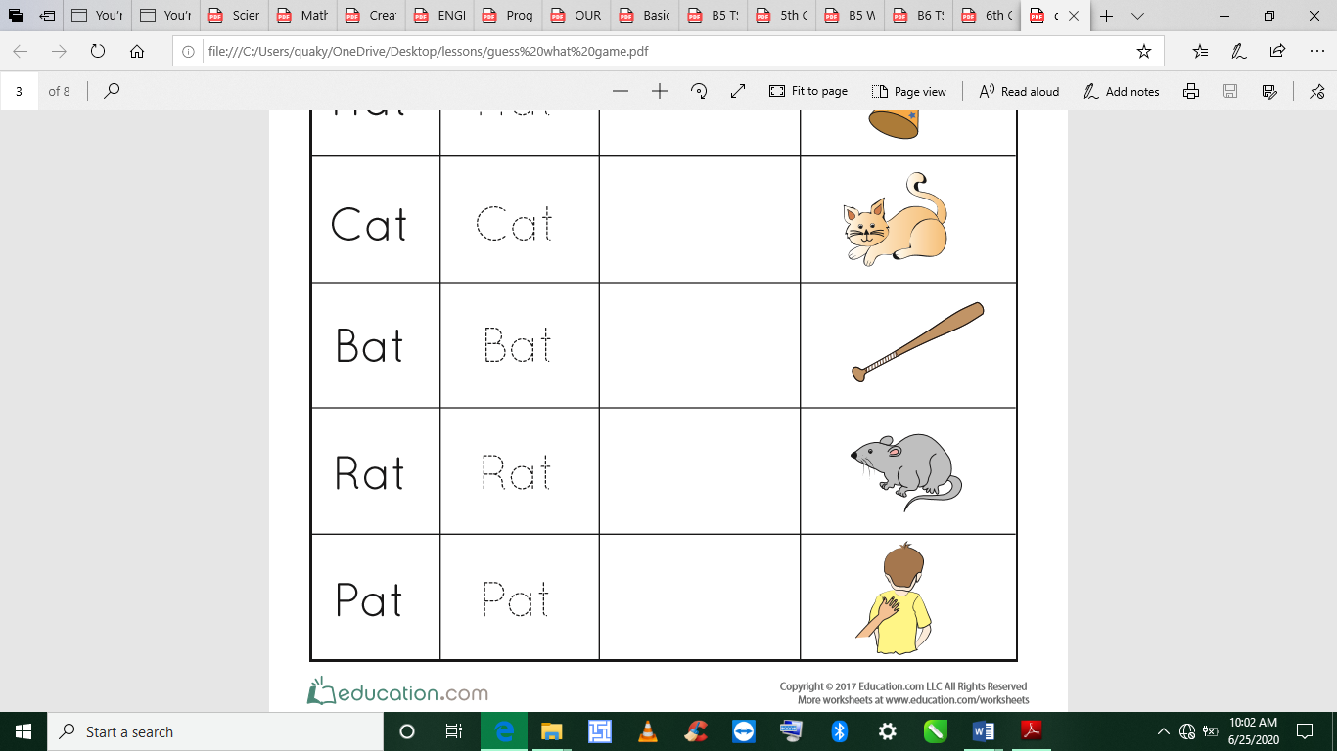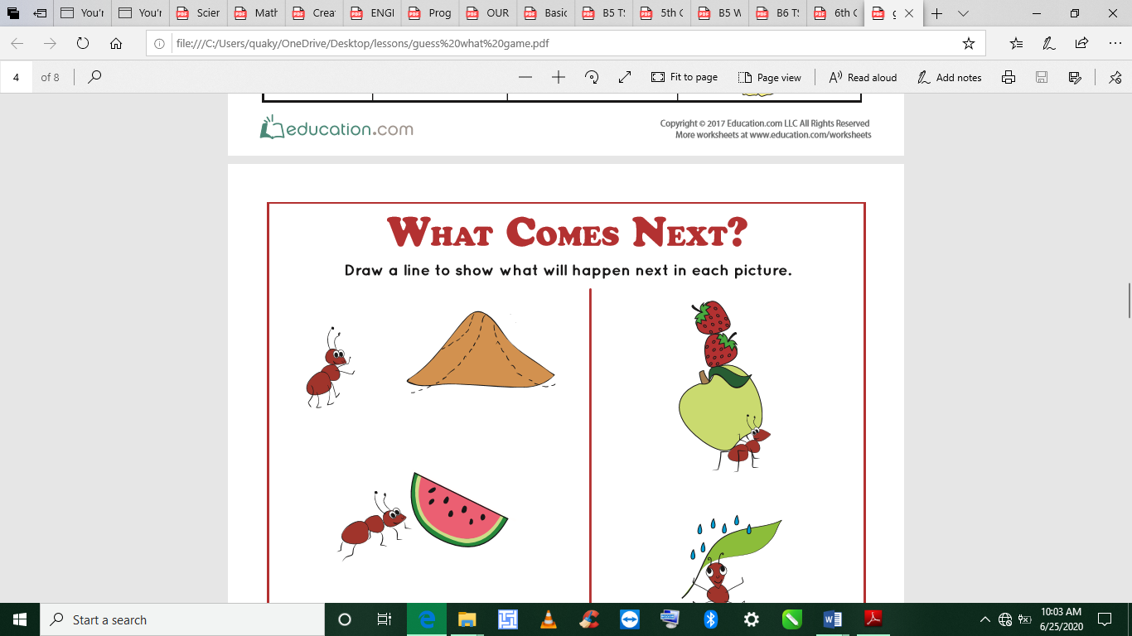  Show flashcards one by one: “Soil,” “Sand,” “Clay,” “Loam,” “Plant.”  Have children repeat the words aloud as they point to the word.  Place the cards on a board or table for reference throughout the lesson.
PHASE 2: NEW LEARNING  CIRCLE TIME | Book: "Planting a Rainbow" or short teacher-made soil story  As you read the story aloud, track each word with your finger under the text.  Encourage children to point to words they recognize on the page (especially vocabulary words).  Pause and let children repeat key words after you, e.g., “This is soil. Say soil.”  Ask comprehension questions:  - “What do we grow in soil?”  - “What color is soil?” |  |  |  |  |  | Young seedlings, pictures of the types of soil, the big book, plastic containers, counters, soil etc.
GROUP ACTIVITY 1  (OUTDOOR) | Take learners outside to touch and explore real soil.  Ask children to use new vocabulary in simple phrases:  - “This is sand.”  - “Clay is hard.”  - “Loam is soft.”  Encourage two-word or three-word phrases:  - “Brown soil.”  - “Sticky clay.” |  |  |  |  |  | Sample young plants, pictures, the Big book, pencils and crayons
PHONICS | Engage learners to sing songs and recite some familiar rhymes that relates to the target sound.  Guide learners to pronounce and write the target sound in the sand tray or exercise books.  Have learners say three or four words that contain the target sound.  Using flash cards, learners read words that contain the target sound.  1. What sound have we learnt today?  2. Which other letter sound do you know?  3. Mention any object in the classroom or home that begins with the target letter sound. |  |  |  |  |  | Word cards, letter cards.
GROUP ACTIVITY 2  (INDOOR) | Match word cards to picture cards (e.g., “Loam” to a soft soil image).  After matching, children say simple sentences aloud:  - “Loam is soft.”  - “Sand is dry.”  - “We plant in loam.”
LEARNING CENTER | Engage learners to play freely at the learning centers.  Observe, join in and ask learners questions frequently to guide their play and to support their understanding in what they are learning. |  |  |  |  |  | Learning center
STORY SHARING | Tell learners a story.  Pause regularly and ask questions to make sure learners are following.  Engage learners to act parts of the story.  1. Was the story interesting?  2. What part of the story did you like?  3. what have you learnt from the story? |  |  |  |  |  | Word cards, letter cards.
PHASE 3:  REFLECTION | Review lesson with Learners by singing songs in relation to it  Let each child choose one soil word and say a sentence about it while pointing to the words:  - Teacher writes the sentence on the board.  - Children point and say the sentence together.

